15th Conference on Wind Engineering – IN-VENTO 2020

Politecnico di Milano, IT

6 – 9 September 2020

**Strong wind characteristics in the Norwegian fjord related to the floating bridge design**

Jungao Wang 1,2, Etienne Cheynet 3, Helle Kristine Fhur 1,

Jasna Bogunović Jakobsen2, Guy Larose4

*1Norwegian Public Roads Administration, Stavanger, Norway*

*2University of Stavanger, Stavanger, Norway*

*3 University of Bergen, Bergen, Norway; 4RWDI, Guelph, Canada*

**SUMMARY:**

This paper focuses on the strong wind events, captured by sonic anemometers in the vicinity of a fjord at the west coast of Norway. 30 storm events are analyzed for the storm evolution and wind statistics. Spectral analysis is performed considering various lengths of the analyzed time-series, target frequency range and different pre-processing procedures. Numerical fitting of empirical wind spectra is also carried out and compared to the reference spectral models from the literature. The wind coherences are also investigated, in relation to the recommended functions in the standards. All the above statistics are then discussed based on different factors, such as the mean wind direction, wind stationarity and length of the analyzed time-series etc. The presented results aim to provide additional insights of the wind parameters for the floating bridge design, based on the strong wind records on the planned bridge site.

*Keywords: Strong wind, wind spectra, wind coherences, floating bridge design*

# INTRODUCTION

Norwegian Public Roads Administration is planning a 5-km long floating bridge across the Bjørnafjord, aiming to increase the transportation efficiency along the E39 route in the west coast of Norway. The Bjørnafjord and the surrounding topography is presented in Figure 1. The potential floating bridge crossing and four land-based wind masts are marked in Figure 1 as well. Each wind mast has 3 Gill WindMaster Pro sonic anemometers.



**Figure 1.** Bjørnafjorden floating bridge layout and the wind mast locations

The latest concept of the floating bridge has the first horizonal mode with the eigen-period of 56 s and the first vertical mode with the period of 6.9 s. A total 30 strong wind events are picked out for the analysis. Event by event investigation is performed by looking into the stationarity, turbulence intensity, wind spectra and coherence. Figure 2 illustrates the wind direction and along-wind speed variation at the top sensors on all four masts during one strong wind event. Figure 3 shows the 1-hour time series of different wind components recorded from the top sensor at Osp1 and the corresponding normalized wind spectra, compared with fitted analytical spectra and reference spectra from literature. The full-length paper will include more detailed information and further expand on the observed turbulence characteristics, particularly in the frequency range relevant to the bridge dynamic response.

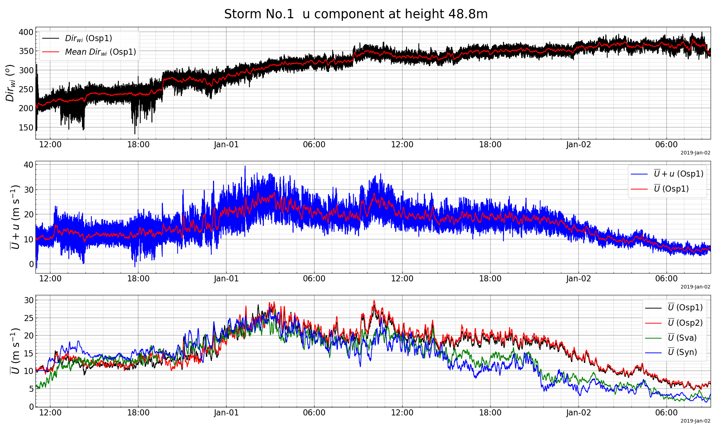

**Figure 2.** Wind characteristics (u components) at the Bjørnafjord site from 2018-12-31 to 2019-01-02

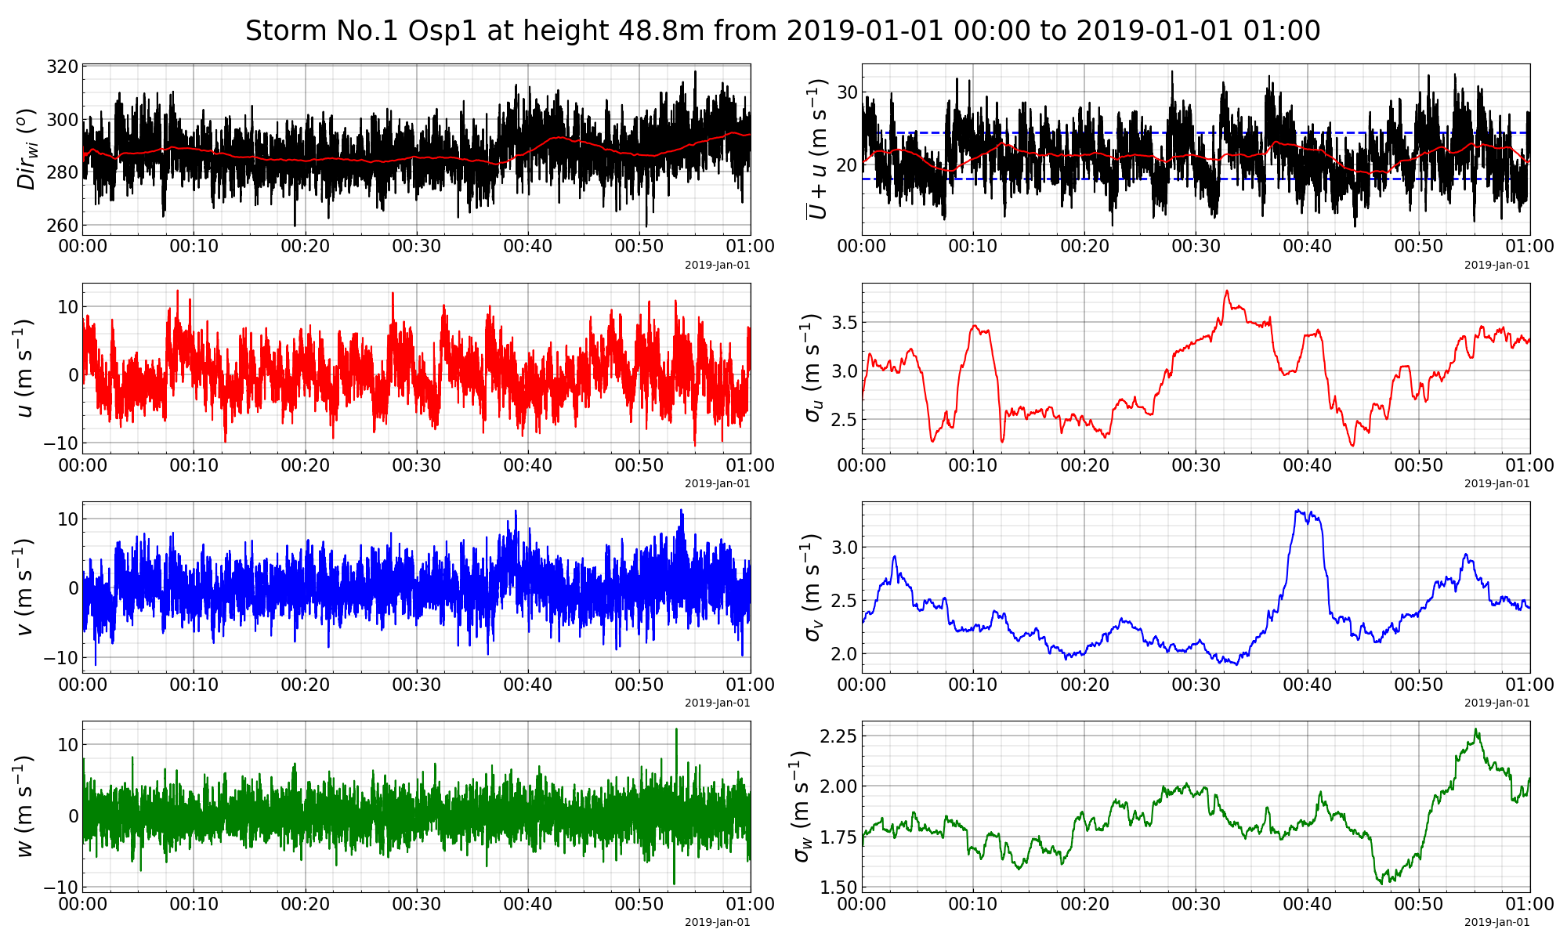

**Figure 3.** Wind characteristics for a one-hour event based on the top sensor at Osp1

**Table 1.** Information of the wind masts and sensors

|  |  |  |  |  |
| --- | --- | --- | --- | --- |
| Location | Ground height | Sensor height  (A, B, C) | Installation date | Note |
| Ospøya 1 (Osp1) | 23 m | 48.8, 48.8 ,33.1 m | 2015-12-03 | Horizontal distance of 8 m for the two top sensors |
| Ospøya 2 (Osp2) | 34 m | 48.8, 48.8 ,33.1 m | 2015-12-17 |
| Svarvhelleholmen (Sva) | 5 m | 48.3, 31.9, 12.7 m | 2015-03-18 |  |
| Synnøytangen (Syn) | 26 m | 48.3, 31.9, 12.7 m | 2015-02-23 |  |

# Sensitivity on wind spectra fitting

It is understandable that there are always discrepancies between the measured wind spectra and those empirical ones suggested in standards or guidelines, especially considering the role of local topography of the measuring locations. In this section, several different empirical wind spectra are reviewed and spectral parameters in these empirical spectra are fitted for comparison. Statistical variation of the fitted parameters is also discussed.

According to the bridge design handbook N400 (Vegvesen, 2015) in Norway, the wind spectra can be characterized by the Eq.(1), which adopts the same definition in the Eurocode for wind actions on structures (En, 1991):

|  |  |
| --- | --- |
| $$S_{fi_n}=\frac{fS_{fi}}{σ_{i}}=\frac{A_{i}{\hat{f}}_{i}}{{\left(1+1.5A_{i}{\hat{f}}_{i}\right)}^{5/3}};i=u, v, w$$ | (1) |

in which $σ_{i}$ is the standard deviation of the wind turbulence; $f$ is the frequency in Hz; ${\hat{f}}_{i}$ is the reduced frequency defined by $\hat{f}=fL_{ix}(z)/V(z)$; $V(z)$ and $L_{ix}(z)$ are the height dependent mean and wind speed length scale; $L_{ux}(z)=100{(z/10)}^{0.3}$ and $L_{vx}\left(z\right)=1/4L_{ux}(z)$, $L_{wx}\left(z\right)=1/12L_{ux}(z)$; $S_{fi}$ is the raw power spectral density for the $i^{th}$ wind component; $S_{fi_n}$ is the normalized power spectral density and $S_{fi_n}$ always has the same peak value at around 0.22; $A_{i}$ is the only parameter that controls the locations of the spectral peak of the normalized wind spectra, the spectra peaks shifts right when $A_{i}$ is smaller, N400 suggests $A_{u}=6.8,A_{v}=9.4, A_{w}=9.4.$ Eq.(1) is noted as one parameter N400 wind spectra in the following context.

By replacing $1.5A_{i}$ in Eq.(1) with another independent parameter $B_{i}$, we can have two-parameter wind spectra:

|  |  |
| --- | --- |
| $$S_{fi_n}=\frac{fS_{fi}}{σ_{i}}=\frac{A_{i}{\hat{f}}_{i}}{{\left(1+B_{i}{\hat{f}}_{i}\right)}^{5/3}};i=u, v, w$$ | (2) |

in which a combination of $A_{i}$ and $B_{i}$ can therefore control the height and location of the spectral peak of the normalized wind spectra. Eq.(2) is noted as two parameters N400 wind spectra in the following context.

Harris spectrum (Harris, 1968) described in Eq.(3) is also used for spectra fitting for the u component of the wind:

|  |  |
| --- | --- |
| $$S_{fu_n}=\frac{fS_{fu}}{σ_{u}}=\frac{A_{u}{\hat{f}}_{u}}{{\left(1+B_{u}{{\hat{f}}_{u}}^{2}\right)}^{5/6}}$$ | (3) |

in which the reference value for $A_{u}=4$ and $B_{u}=70.8$.

Typically, both N400 and Harris spectrum with default values are meant to describe the wind in land for 10-minute wind events. For offshore structures where excitation in the low-frequency range is of importance, Frøya spectrum (Andersen and Løvseth, 2006) in Eq.(4) is recommended for wind over water:

|  |  |
| --- | --- |
| $$S_{fu}=320\frac{{(\frac{U_{10}}{10})}^{2}{(\frac{z}{10})}^{0.45}}{{\left(1+{\tilde{f}}^{0.468}\right)}^{\frac{5}{3}*0.468}}; \tilde{f}=172f{(\frac{z}{10})}^{2/3}{(\frac{U_{10}}{10})}^{-0.75}$$ | (4) |

in which $U_{10}$ is the 1-hour mean wind speed at 10 m height. Frøya spectrum is not used for spectral fitting due to the complex structure of the empirical formula, but it was plotted later in the spectral fitting results for comparison.

Busch Panofsky spectrum (Busch and Panofsky, 1968) described in Eq.(5) is used for spectra fitting for the w component of the wind:

|  |  |
| --- | --- |
| $$S_{fw_n}=\frac{fS_{fw}}{σ_{w}}=\frac{A_{w}{\hat{f}}_{w}}{{1+B_{w}{\hat{f}}_{w}}^{5/3}}$$ | (5) |

in which the reference value for $A_{w}=2.15$ and $B_{w}=11.16$.

Numerical fittings were performed in the format of both raw and normalized spectra for strong wind events in the wind measurements. It is worth mentioning that the integral of the normalized spectra along the reduced frequency equals to 1, according to the definition of the normalized spectra. This implies that the standard deviation of the wind turbulence $σ_{i}$, calculated from the measured time series, needs to be used in the spectral fitting to achieve reasonable fitting results. Therefore, the fitted spectral parameters are dependent on $σ_{i}$. Using the deterministic standard deviation of the wind turbulence at given mean wind speed according to the standard violates the original definition of the normalized wind spectra, and it would lead to a bad fitting for the one-parameter N400 spectra. However, for the empirical wind spectra with two variables, the variation of $σ_{i}$ can be reflected in the fitted $A_{i}$ parameter if the deterministic $σ_{i}$ is used. It is noted that the consistent combination of parameters used for spectral fitting should be used when reconstructing the wind spectra to represent these strong wind events.

An example of the spectral fitting using different empirical spectra is presented in Figure 4 for different wind components. N400 wind spectra with default $A_{i}$ and deterministic $σ_{i}$ are also included in the plots for references. It is clear in the left subplots that reference N400 spectra underestimate the measurements for all three components, and this is to a large extent due to the higher turbulence level in the measurement. For the raw spectral fitting, all fitted curves have a reasonable match with the measurements at the frequency range relevant for the floating bridge design. Based on the fitting of the normalized spectra, the two-parameter fittings show a better agreement, as expected, considering the shape (peak value) of the spectra is flexible. Considering it is the raw spectra that describe the wind energy distribution along frequency that affects the bridge response, the $A_{i}$ from one-parameter raw spectral fitting is discussed in the following context. The variation of fitted $A_{i}$ is dependent on the variation of $σ_{i}$ event by event. It would be equivalent to use the deterministic $σ_{i}$, and a pair of $A_{i}$ and $B_{i}$ to characterize the measured spectra.

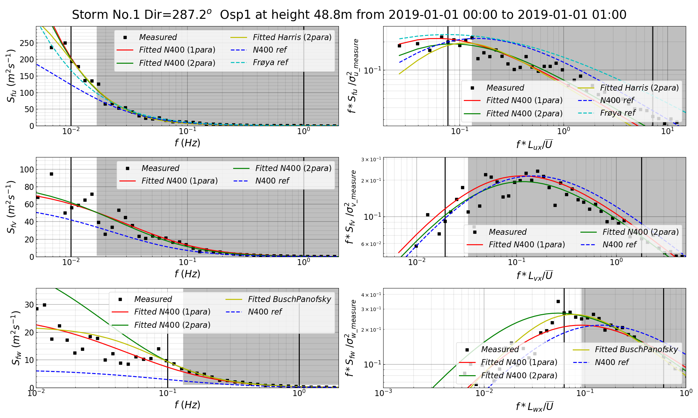

**Figure 4.** Wind spectra fitting considering different wind spectra (left three subplots are the fitting of raw wind spectra for u, v and w components, right three subplots are the fitting of normalized wind spectra for u, v and w components, two vertical black lines indicate the range of frequency for the spectral fitting and the shaded area indicates the frequency above the eigenfrequencies associated with the first horizontal or vertical mode of the proposed floating bridge)

In the numerical processing of the measured data and the curve-fitting, different choices on the value of many controlling parameters might yield different fitting results. Table 2 summarizes the combination of some variables for the spectral fitting, used for sensitivity study based on one of the top sensors at Ospøya 1 during one strong wind event (2019-01-01 00:00 to 2019-01-01 13:00). The sensitivity study covers six different aspects:

1. The spectral type includes raw and normalized spectra, the default choice is made to be the raw spectra;
2. The spectral smoothing parameter controls whether smoothing algorithm in the logarithmic scale will be used or not and the number of bin-averaging points (120, 60 and 30) to be used, the default choice is made to be 60 points;
3. The Welch segment number controls the number of segments (12/ 6/ 3/ 1) to estimate power spectral density using Welch’s method for the measured time series. The default choice is made to be 6 segments;
4. The moving average detrend parameter controls how to detrend the original time series (using the 60/ 20/ 10/ 5 minutes moving averaging values to detrend the original time series), the default choice is made to be 5 minutes;
5. The fitted frequency range controls the spectra correspond to which range of the frequency needs to be fitted, the band frequency in the table indicates 0.01-1 Hz for the u and v component, and 0.1-1Hz for the w component; low frequency range indicates the range below 1Hz are considered; high frequency indicates range above 0.01 Hz for the u, v component and above 0.1Hz for w component. The default choice is made to be the band frequency;
6. The length of time series controls the duration (10/ 20 minutes, 1/ 3 hours) of the event used for spectral analysis and fitting. Here the stationarity changes when the duration of the event changes, in this case, only the 3 hours event from 2019-01-01 06:00 to 2019-01-01 09:00 is used for this sensitivity study. The default choice is made to be 1 hour.

**Table 2.** Summary on the combination of various controlling parameters for wind spectral fitting

|  |  |  |  |  |  |  |
| --- | --- | --- | --- | --- | --- | --- |
|  | Spectral type | Spectral smoothing parameter | Welch segment number | Moving average detrend | Fitted frequency range | Length of time series |
| Spectral type | Raw/ Normalized | Raw | Raw | Raw | Raw | Raw |
| Spectral smoothing parameter | 60 points | w.o smoothing/ 120/ 60/ 30 points | 60 points | 60 points | 60 points | 60 points |
| Pwelch segment numbers | 6 segments | 6 segments | 12/ 6/ 3/ 1 segments | 6 segments | 6 segments | 6 segments |
| Moving average detrend | 5 mins | 5 mins | 5 mins | 60/ 20/ 10 /5 mins | 5 mins | 5 mins |
| Fitted frequency range | Band frequency | Band frequency | Band frequency | Band frequency | Band/ high /low frequency/ full range | Band frequency |
| Length of time series | 1 h | 1 h | 1 h | 1 h | 1 h | 10 mins/ 20 mins/ 1 h /3 h |

Figure 5 presents the distribution of fitted $A_{i}$ parameter considering six aspects mentioned in Table 2. Each column of three subplots shows the variation of $A_{i}$ with time for u, v and w component. The general trend is that $A_{u}$ shows the great variability over time with values larger and smaller than the reference value 6.8 and it is more sensitive to various choice of parameters. $A_{v}$ is less time-varying and less sensitive to controlling parameters. $A_{w}$ is relatively stable over time and not sensitive to most of the controlling parameters other than the fitted range of frequency and duration of the analyzed time series. $A_{w}$ is always above the reference value of 9.4 for the entire time.

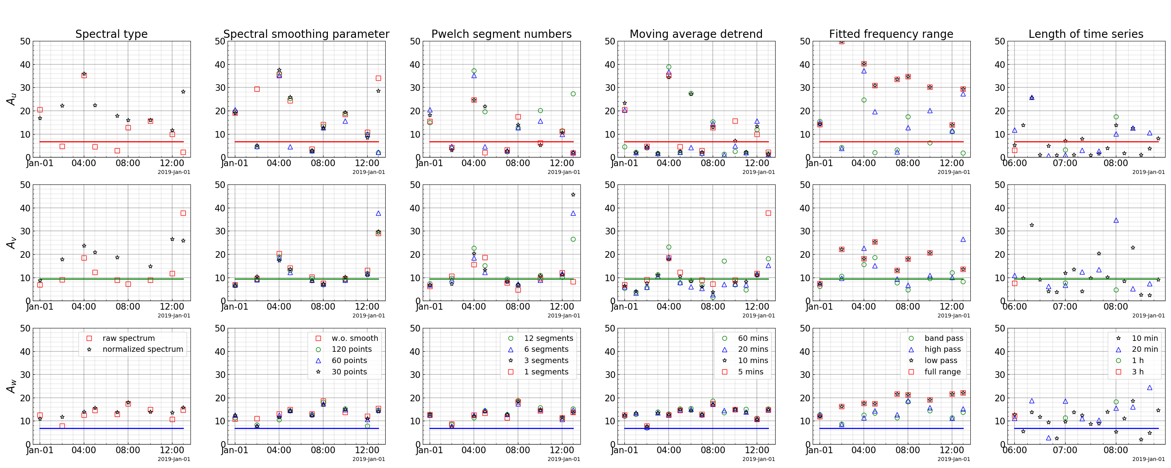

**Figure 5.** Summary plot on sensitivities of various controlling parameters for wind spectral fitting (each colored straight line in the subplot represents the reference value of $A_{u}=6.8; A_{v}=9.4; A_{w}=9.4$)

Figure 6 presents the fitted $A_{i}$ considering all the six top sensors from four wind masts using the default choice of the six controlling parameters. The mean wind speed, wind direction and the turbulence intensity are also included in the figure for reference. The comparison indicates much higher turbulence intensity at Synnøytangen compared to the rest of the masts. The mismatch is also observed for the fitted $A_{i}$ at different masts, most of the outliers occur at two masts at two sides of the fjord and $A_{u}$ experiences a larger scatter among different sensors.

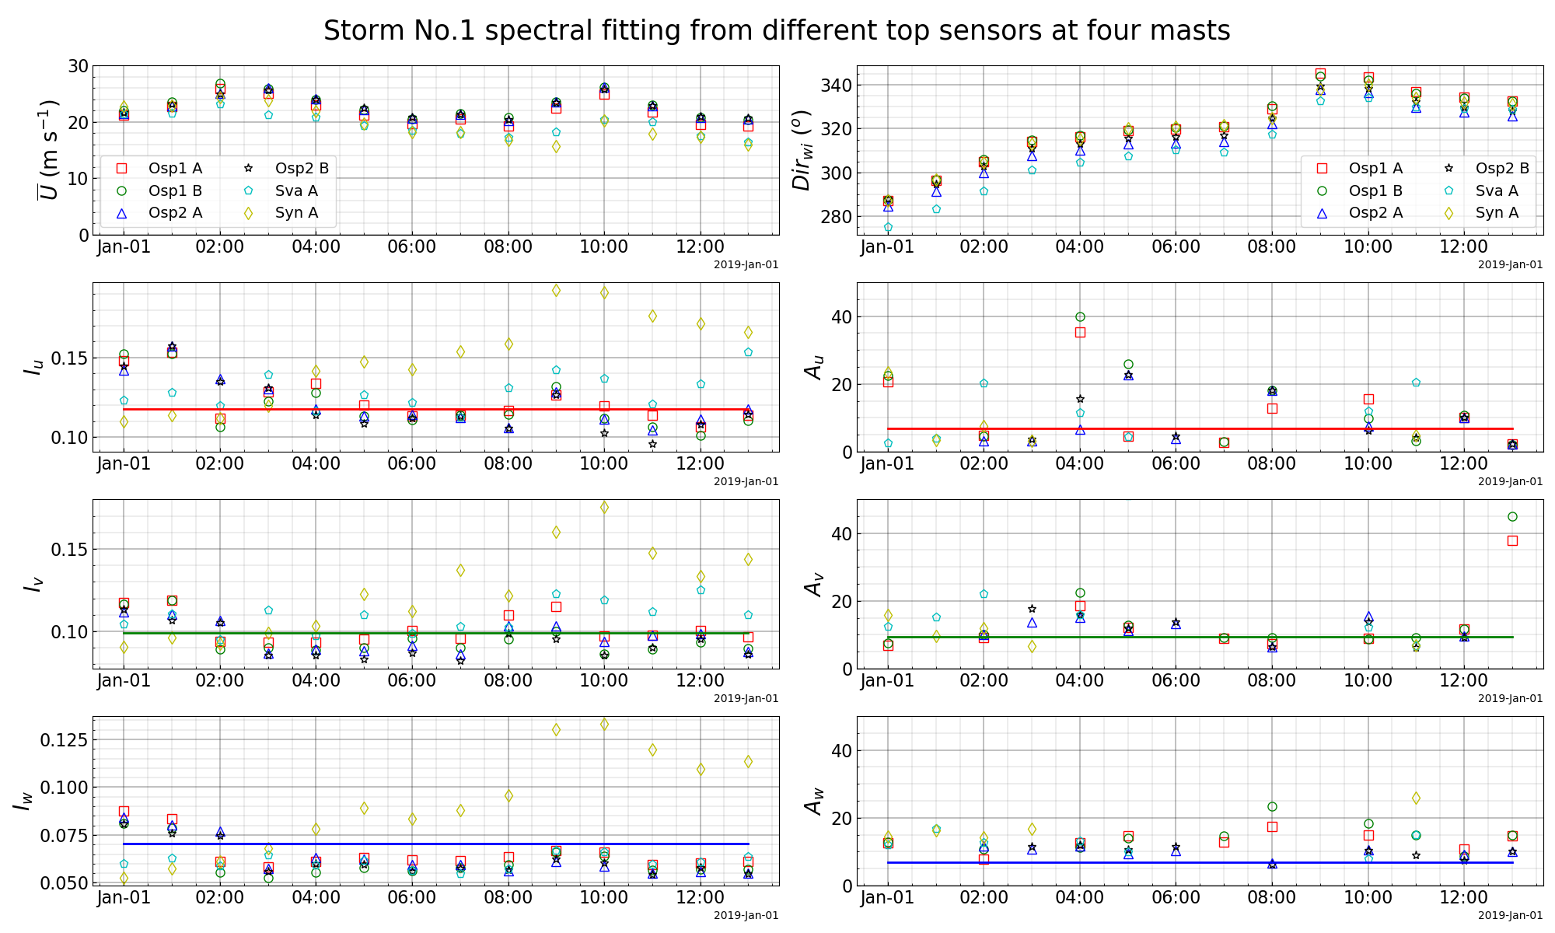

**Figure 6.** Comparison on the fitted A parameters in the wind spectra from sensors at different masts

# Sensitivity on wind coherence fitting

Eq. (6) and Eq. (7) are used to describe the wind coherence:

|  |  |
| --- | --- |
| $${Coh}_{i_hor}=e^{-1\left(\frac{f}{0.5(V\left(z_{1}\right)+V\left(z_{2}\right))}\sqrt{\left({\left(C_{ix}dx\right)}^{2}+{\left(C_{iy}dy\right)}^{2}\right)}\right)} ;i=u,v,w$$ | (6) |
| $${Coh}_{i_ver}=e^{-1\left(\frac{f}{0.5(V\left(z_{1}\right)+V\left(z_{2}\right))}C_{iz}dz\right)} ;i=u,v,w$$ | (7) |

in which $f$ is the frequency in Hz; $V(z_{1})$ and $V(z_{2})$ are the mean wind speed at two different locations; $dx$, $dy$ and $dz$ are the separation length of the two wind components along the longitudinal, lateral and vertical directions; $C_{ix}$, $C_{iy}$ and $C_{iz}$ are the coherence coefficients for the $i^{th}$ wind component along three different directions. According to N400, $C_{uy}=C_{uz}=10; C_{vy}=C_{vz}=C_{wy}=6.5; C_{WZ}=3$. A smaller coherence coefficient suggests two signals are more coherent at the same frequency or same distance.

Two top sensor A and B at the same elevation at wind mast Ospøya1 and Ospøya2 are used to calculate the wind coherence for horizontal separation in Eq. (6), and sensor A and C are used to calculate the wind coherence for vertical separation in Eq. (7).

An example of the coherence fitting is presented in Figure 7. The comparison shows that all three wind components in the horizontal plane are more coherent than the reference values. The vertical separation is close to and slightly less coherent than the reference value.

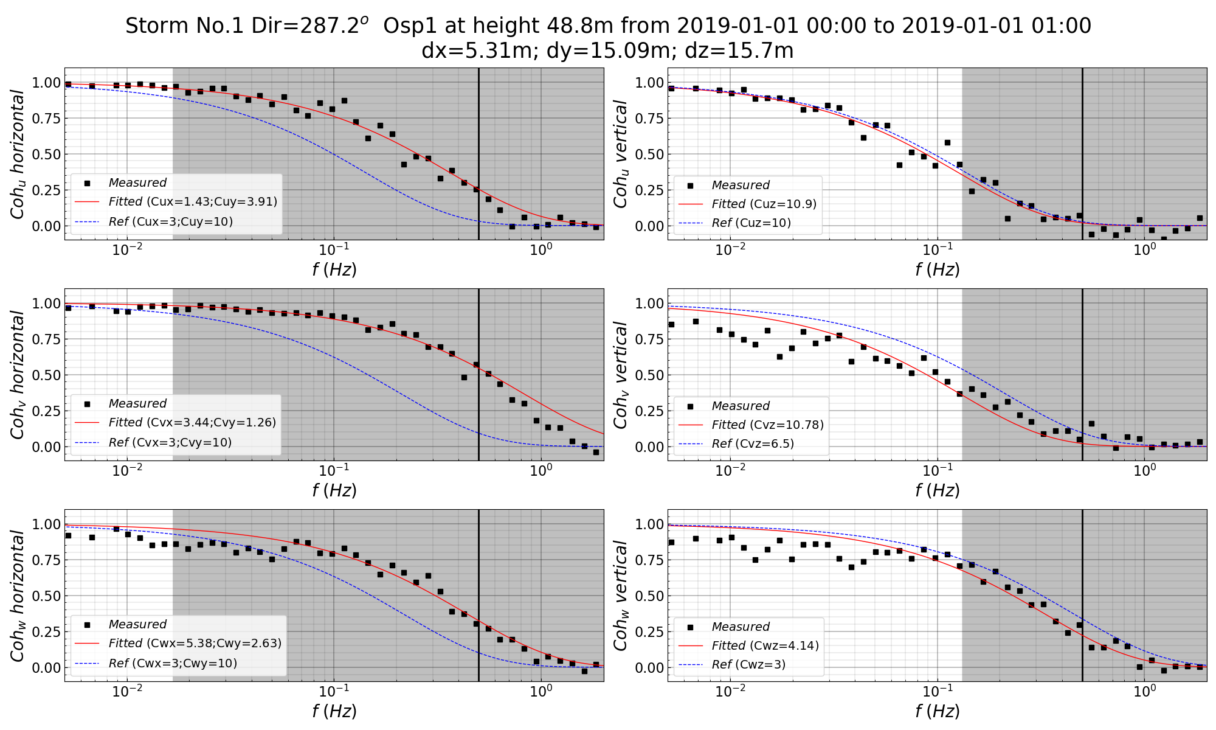

**Figure 7.** Wind coherence fitting (left three subplots are the fitting of the wind coherence in the horizontal plane, right three subplots are the fitting in the vertical plane, two vertical black lines indicate the upper bound of the frequency range for the fitting and the shaded area indicates the frequency above the eigenfrequencies associated with the first horizontal or vertical mode of the proposed floating bridge)

Like the sensitivity study on the controlling parameters in the spectral fitting, Table 3 summaries similar controlling parameters for the co-spectral analysis.

**Table 3.** Summary on the combination of various controlling parameters for wind coherence fitting

|  |  |  |  |  |  |
| --- | --- | --- | --- | --- | --- |
|  | Spectral smoothing parameter | Welch segment numbers | Moving average detrend | Fitted frequency range | Length of time series |
| Spectral smoothing parameter | w.o smoothing/ 120/ 60/ 30 points | 60 points | 60 points | 60 points | 60 points |
| Pwelch segment numbers | 6 segments | 12/ 6/ 3/ 1 segments | 6 segments | 6 segments | 6 segments |
| Moving average detrend | 5 mins | 5 mins | 60/ 20/ 10 /5 mins | 5 mins | 5 mins |
| Fitted frequency range | 0-0.5 Hz | 0-0.5 Hz | 0-0.5 Hz | 0-0.5/ 0-1/ 0.01-1 Hz / full | 0-0.5 Hz |
| Length of time series | 1 h | 1 h | 1 h | 1 h | 10 mins/ 20 mins/ 1 h /3 h |

Figure 8, Figure 9 and Figure 10 presents the coherence coefficient sensitivity on six different aspects along the longitudinal, lateral and vertical directions respectively. The general trend is that the coefficients for the longitudinal speration experience the most abrupt variation with time compared to the coefficients for the lateral and vertical separation. The coefficients for the longitudinal and lateral separation are sensitive on the choice of the controlling parameters, compared to the vertical separation is less sensitive.

Another observation is that most of the coefficients for the longitudinal and lateral separation are much smaller than the reference values, indicating a much coherent wind for the separation in the horizontal plane, which would lead to higher wind loads for the curved floating bridge. The coefficients for the vertical separation are close and a bit higher than the reference case. Statistical distribution of these coefficients based on more strong events will be presented and discussed in the next section.

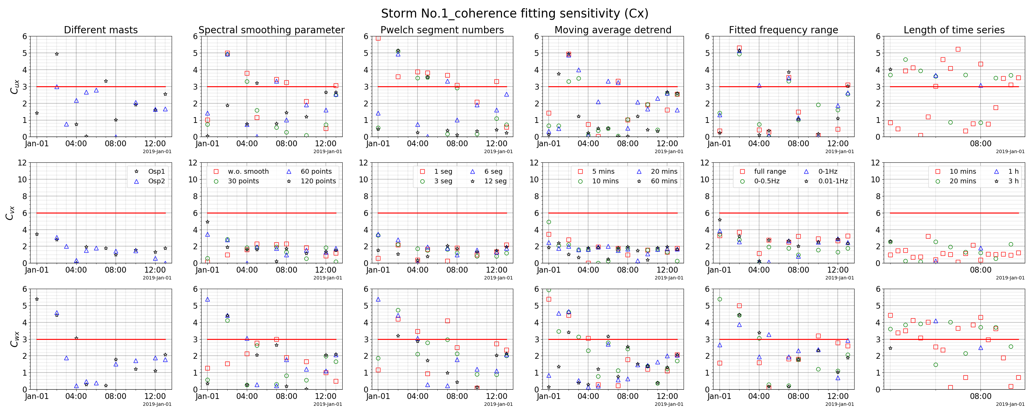

**Figure 8.** Summary plot on sensitivities of various controlling parameters for wind coherence fitting on the longitudinal separation

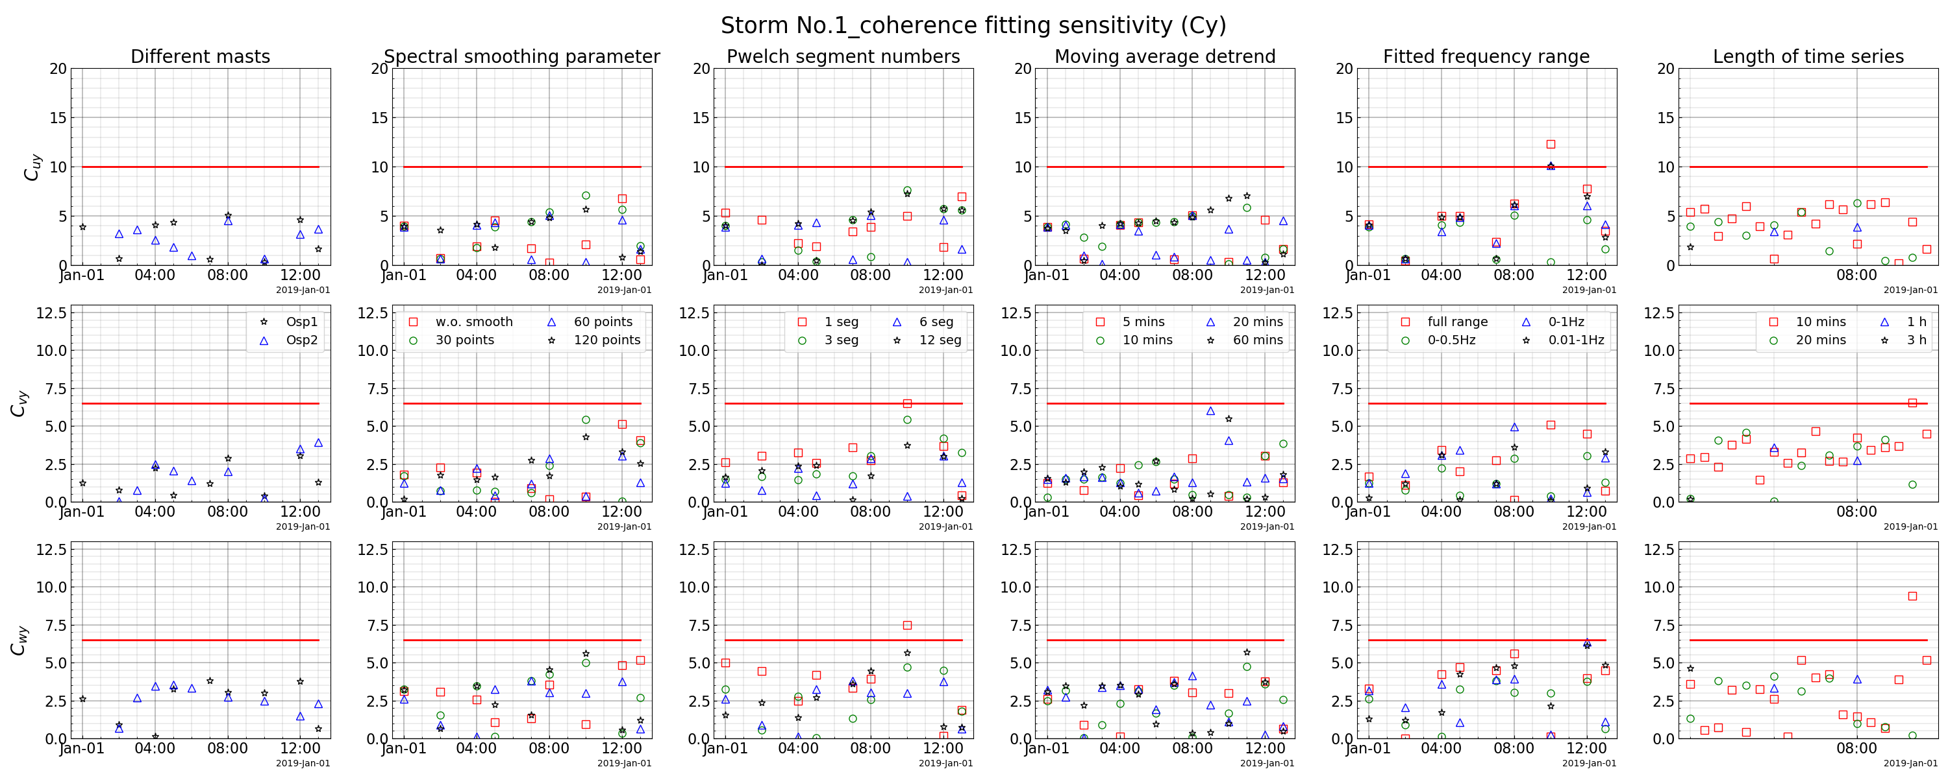

**Figure 9.** Summary plot on sensitivities of various controlling parameters for wind coherence fitting on the lateral separation

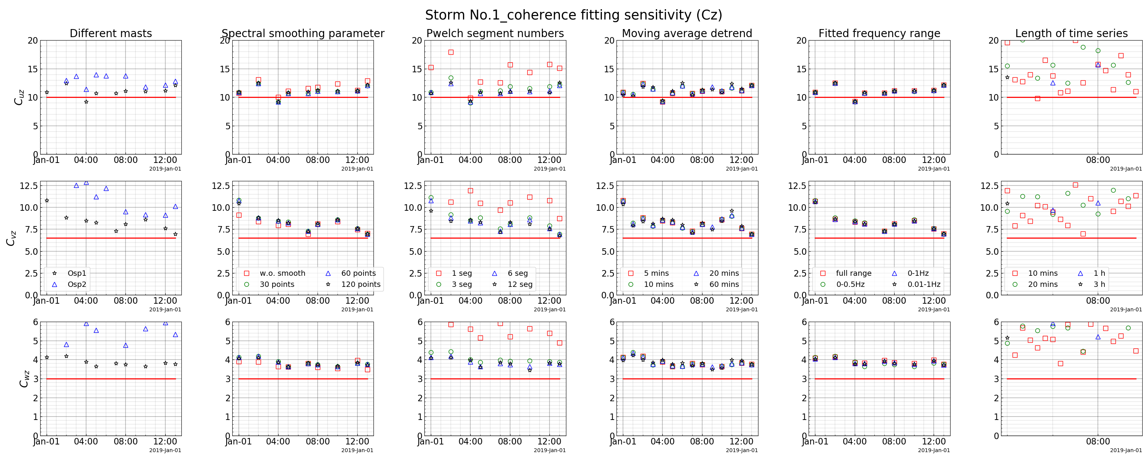

**Figure 10.** Summary plot on sensitivities of various controlling parameters for wind coherence fitting on the vertical separation

# Statistical distribution of the fitted spectral and coherence parameters

Figure 11 presents the distribution of the fitted A parameters based on the identified 11 strong wind events in terms of histograms. Results from all six top sensors are included with a reference value marked by red lines. These plots demonstrate the large scatter of the fitted A parameter at both sides of the reference values.

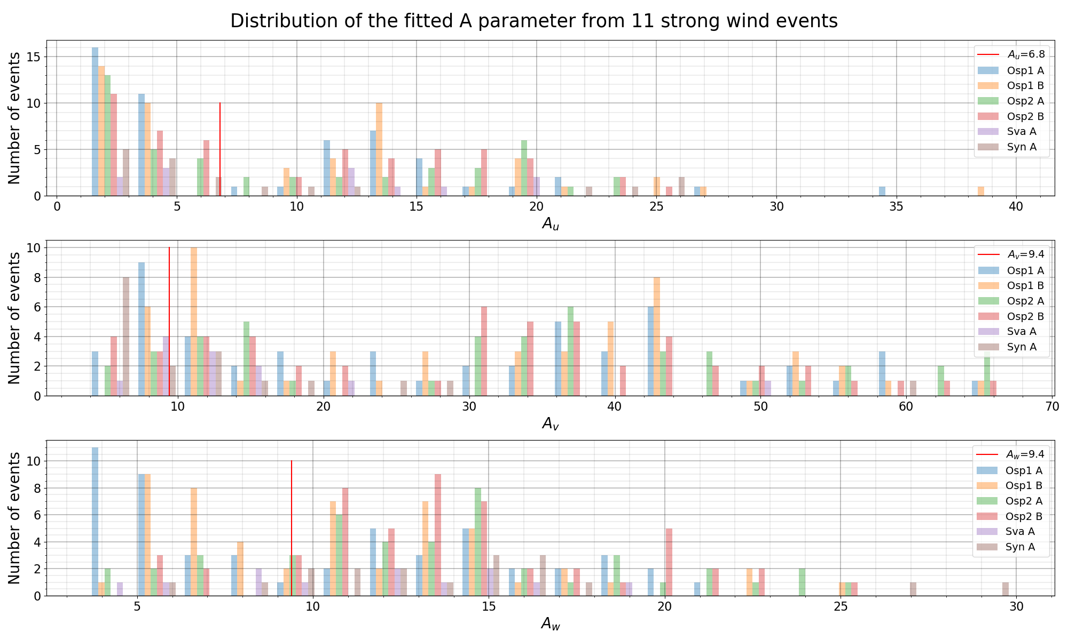

**Figure 11.** Histogram of the fitted A parameters

Figure 12 presents the distribution of the fitted coherence coefficients, the C parameter. It is less scattered compared to the A parameter and most of the coherence coefficients for the horizontal separation are lower than the reference values. For the vertical separation, the coefficients for the u and v component are larger than the reference values, while the coefficient for the w component lies both sides of the reference value. The statistic distribution of the fitted coherence coefficients from the strong wind events presents a overview of the site-specific wind characteristics and provides a basis for further sensitivity studies on the structure response analysis on these wind parameters.

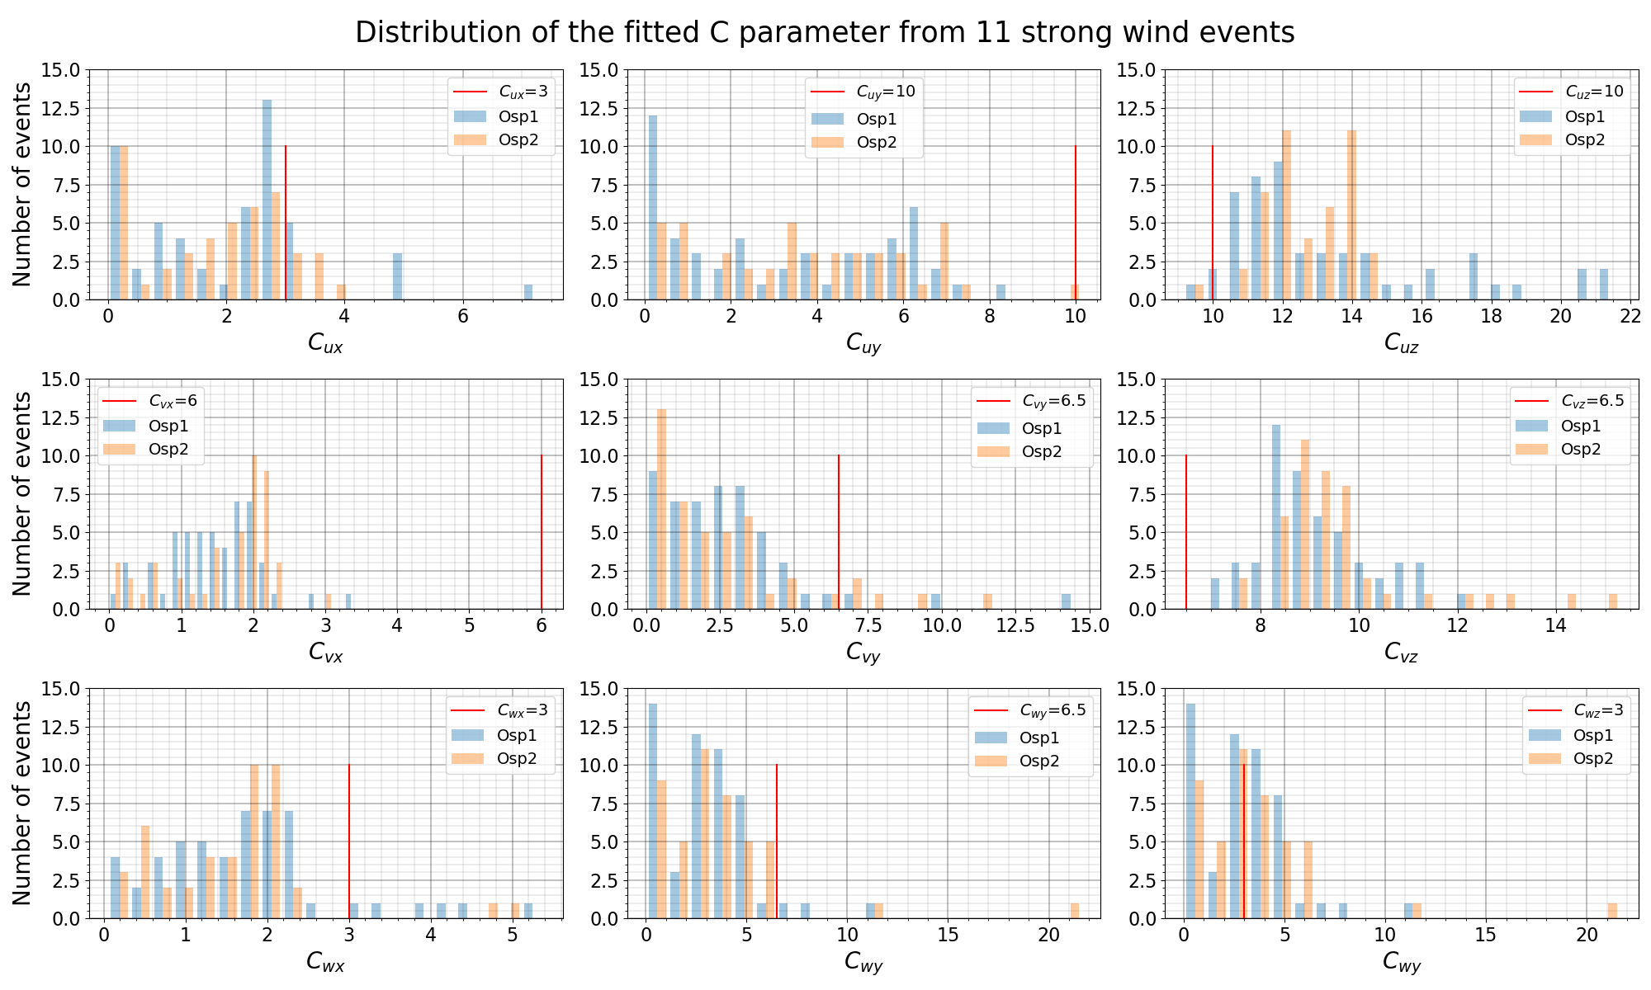

**Figure 12.** Histogram of the fitted C parameters

Figure 13 presents a summary of dependency subplots of various parameters related to single point wind statistics.

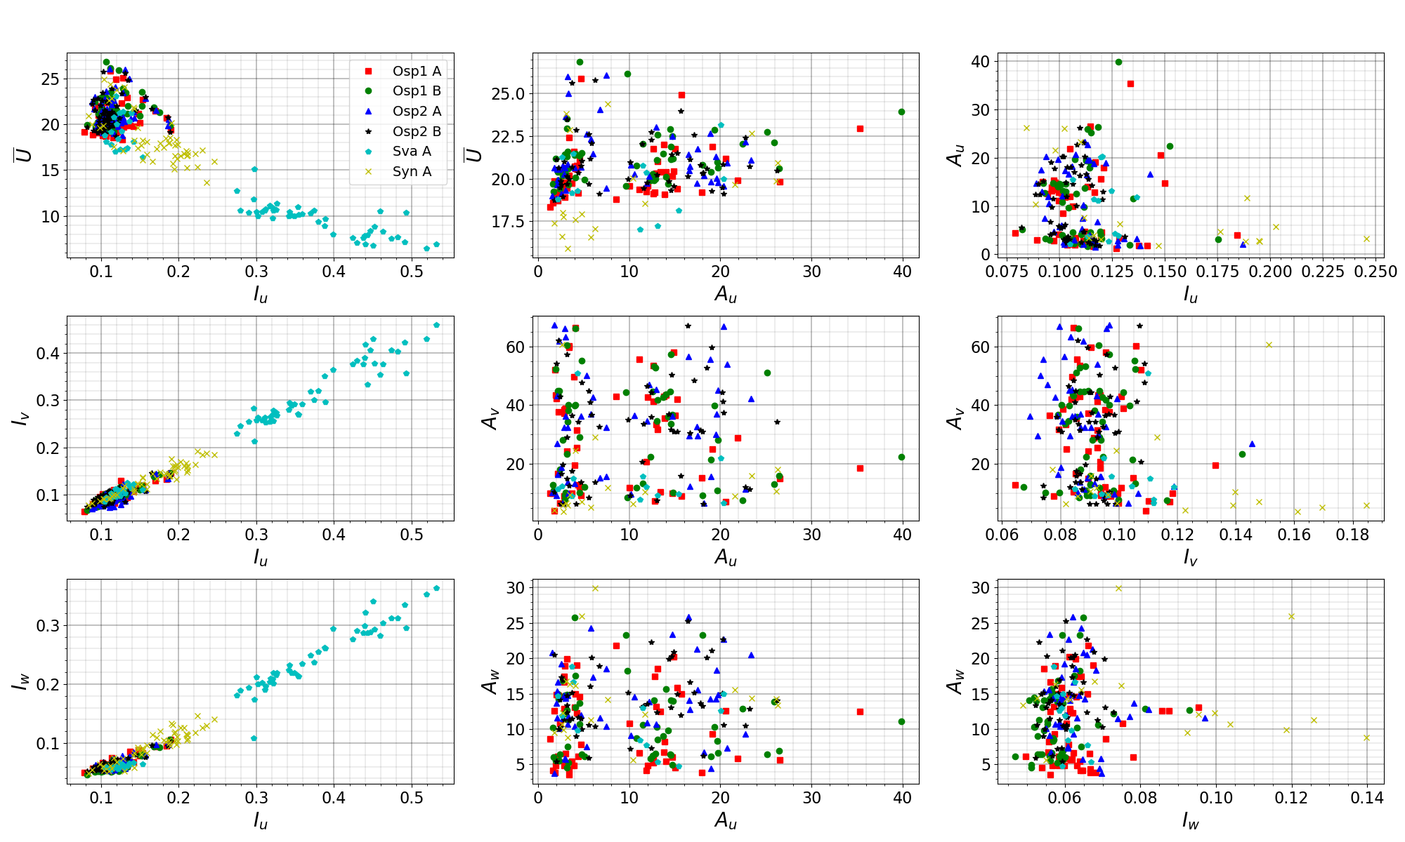

**Figure 13.** A parameter dependency plot

Figure 14, Figure 15, Figure 16 and Figure 17 present dependency subplots of various parameters related to wind coherences.

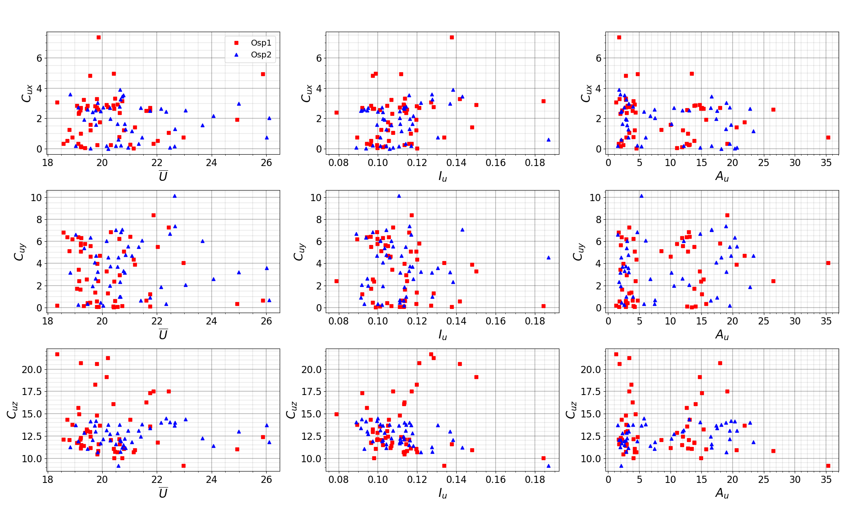

**Figure 14.** Cu parameter dependency plot

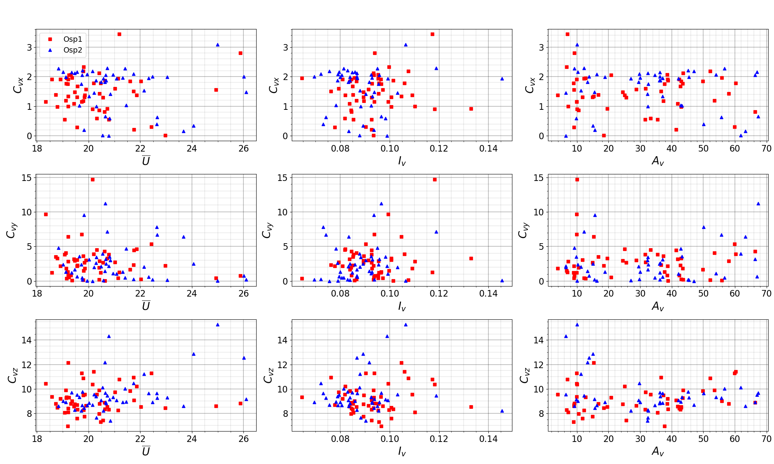

**Figure 15.** Cv parameter dependency plot

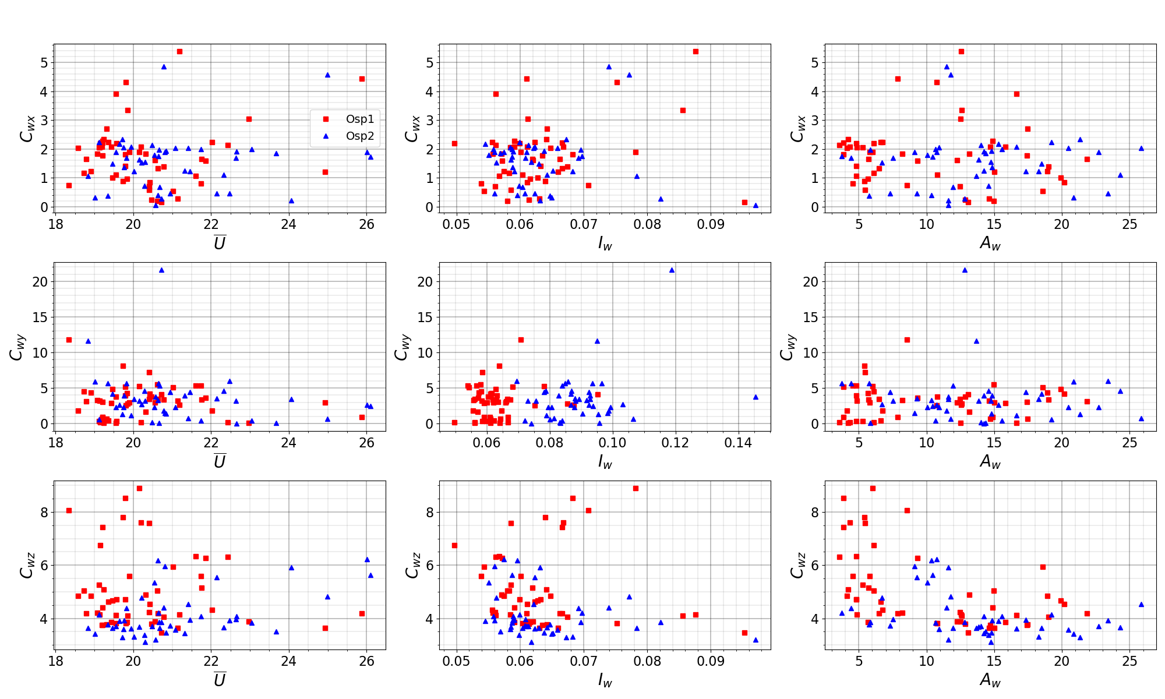

**Figure 16.** Cw parameter dependency plot

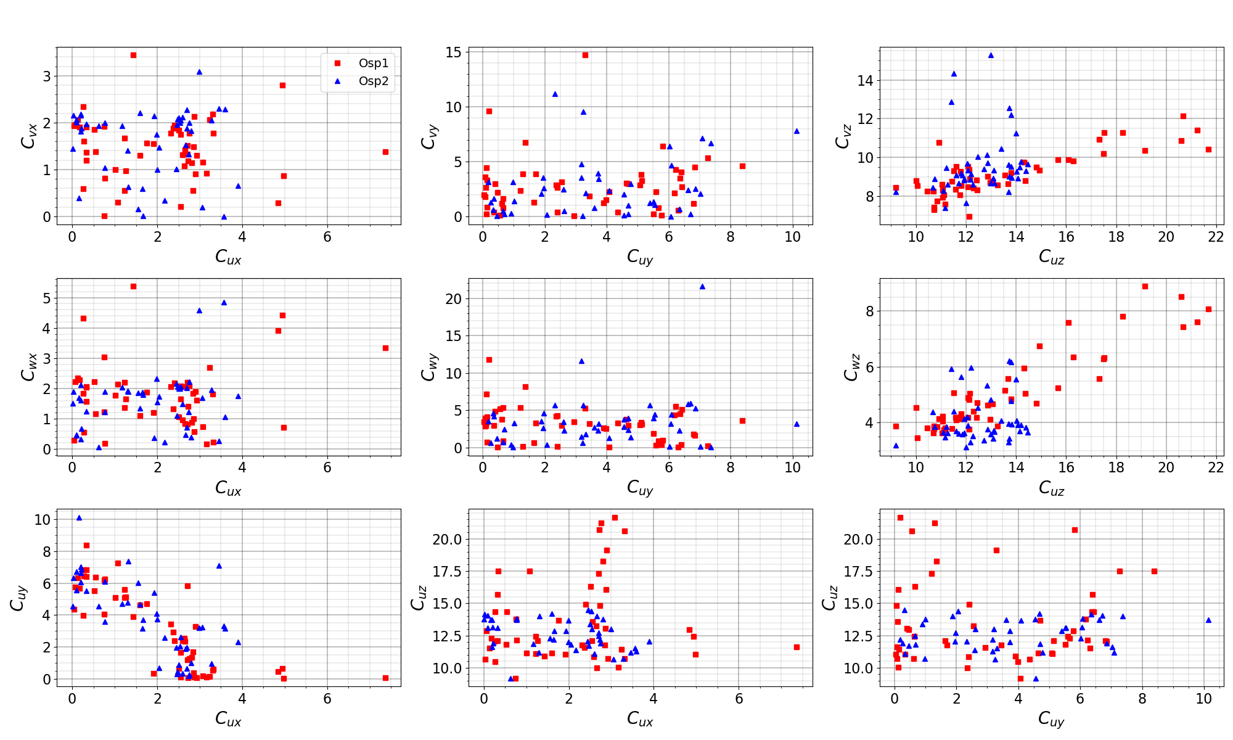

**Figure 17.** C parameter dependency plot

**Reference**

Andersen, O.J., Løvseth, J., 2006. The Frøya database and maritime boundary layer wind description. Marine Structures 19, 173-192.

Busch, N.E., Panofsky, H.A., 1968. Recent spectra of atmospheric turbulence. Quarterly Journal of the Royal Meteorological Society 94, 132-148.

En, B., 1991. Eurocode 1: Actions on structures - Part 1-4 General actions—Wind actions. NA to BS EN.

Harris, R., 1968. On the spectrum and auto-correlation function of gustiness in high winds. Electrical Research Association.

Vegvesen, S., 2015. Håndbok N400 Bruprosjektering. Vegdirektoratet.